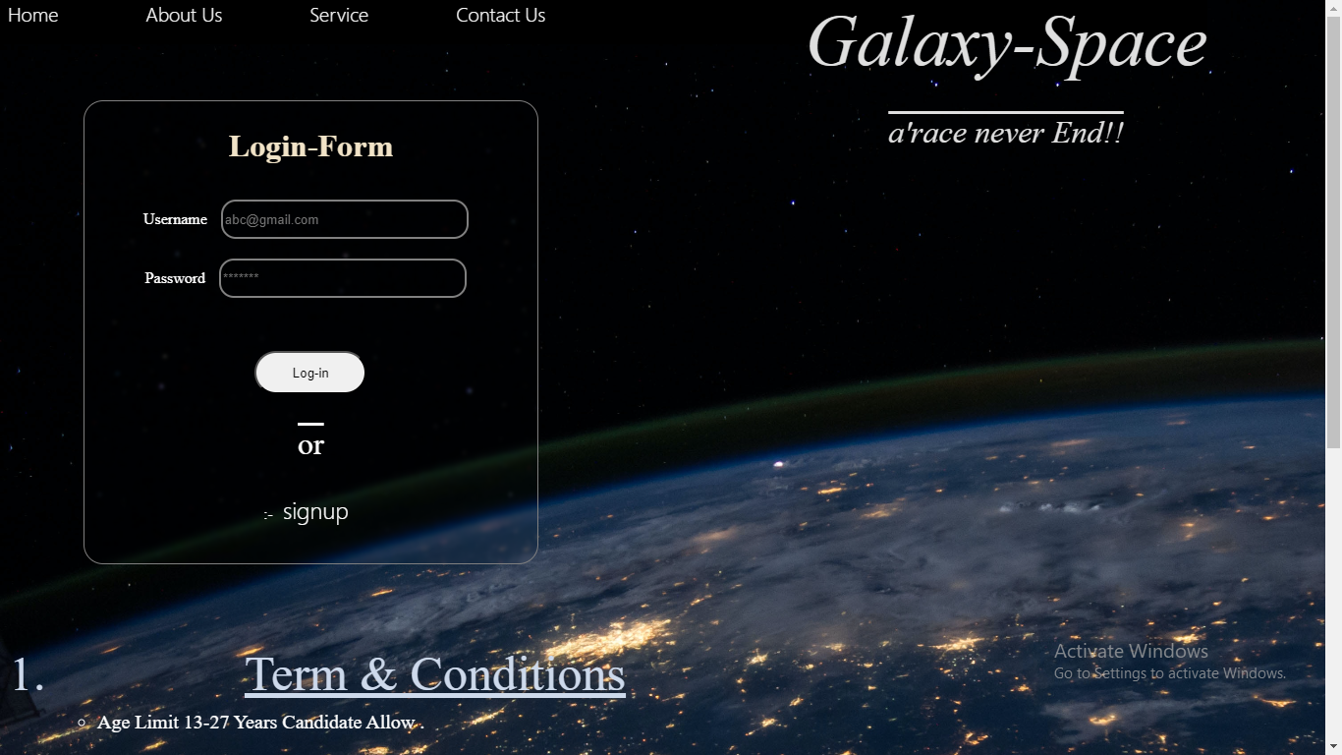

***“Log-In form – step-1”***

**“Its define Rules and go to log-in this website 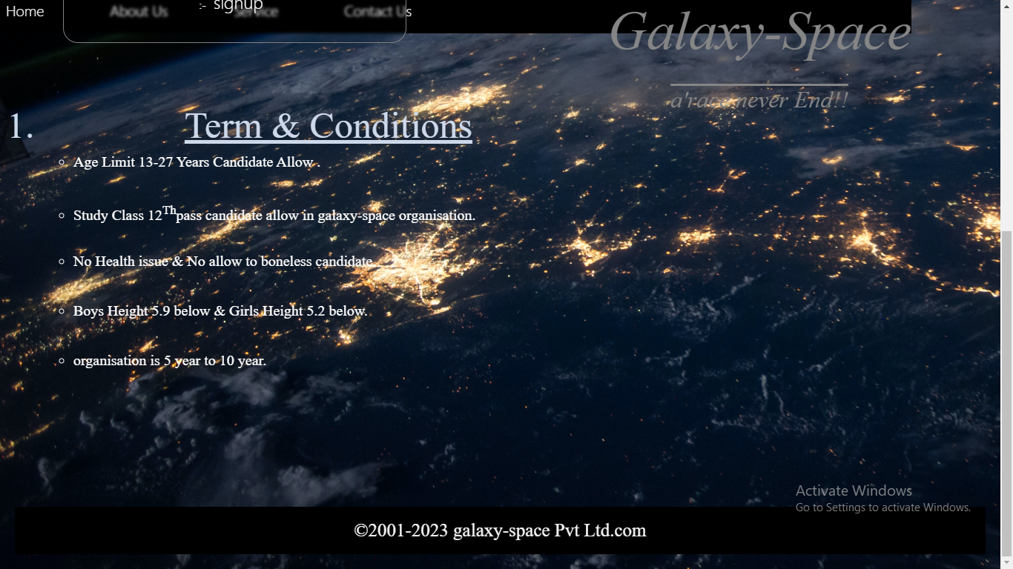(Step-2)”**

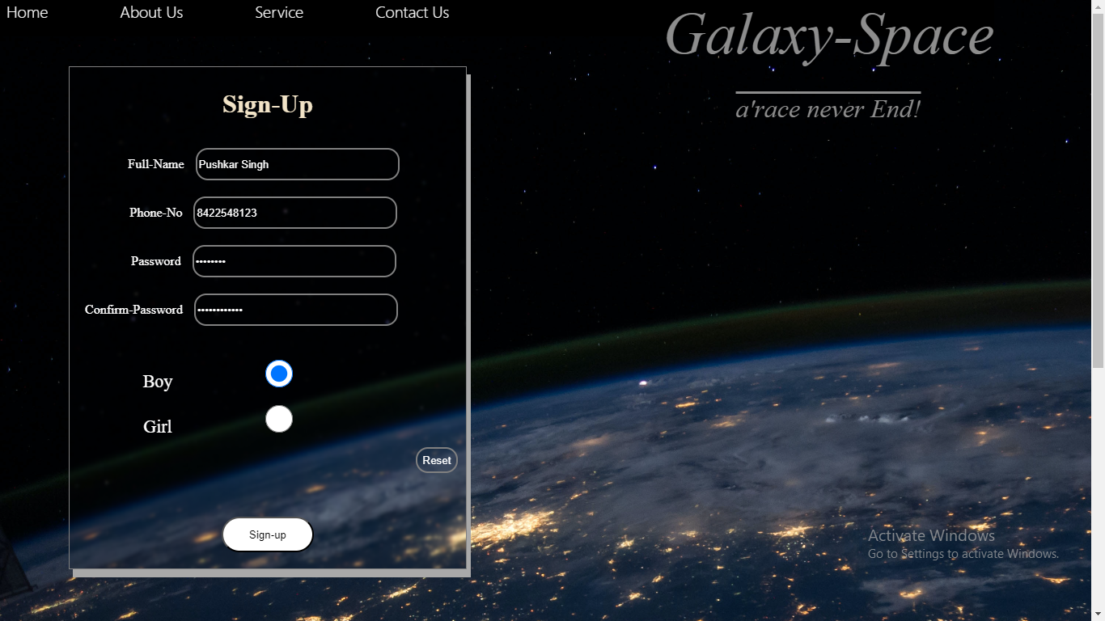**“Give details in signup form”**

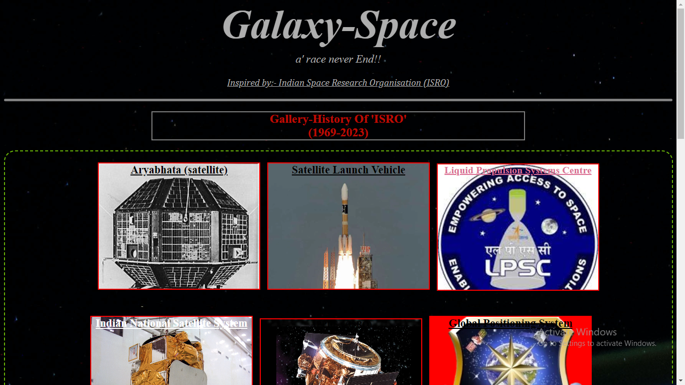**“ISRO :- Gallery visit”**

* A Peacefully website to design to view person a best space journey of ISRO.
* Different image to define a new stories and journies.
* Its not good but its not a poor they give us inspire .
* They Give lesson to never loose your confident.

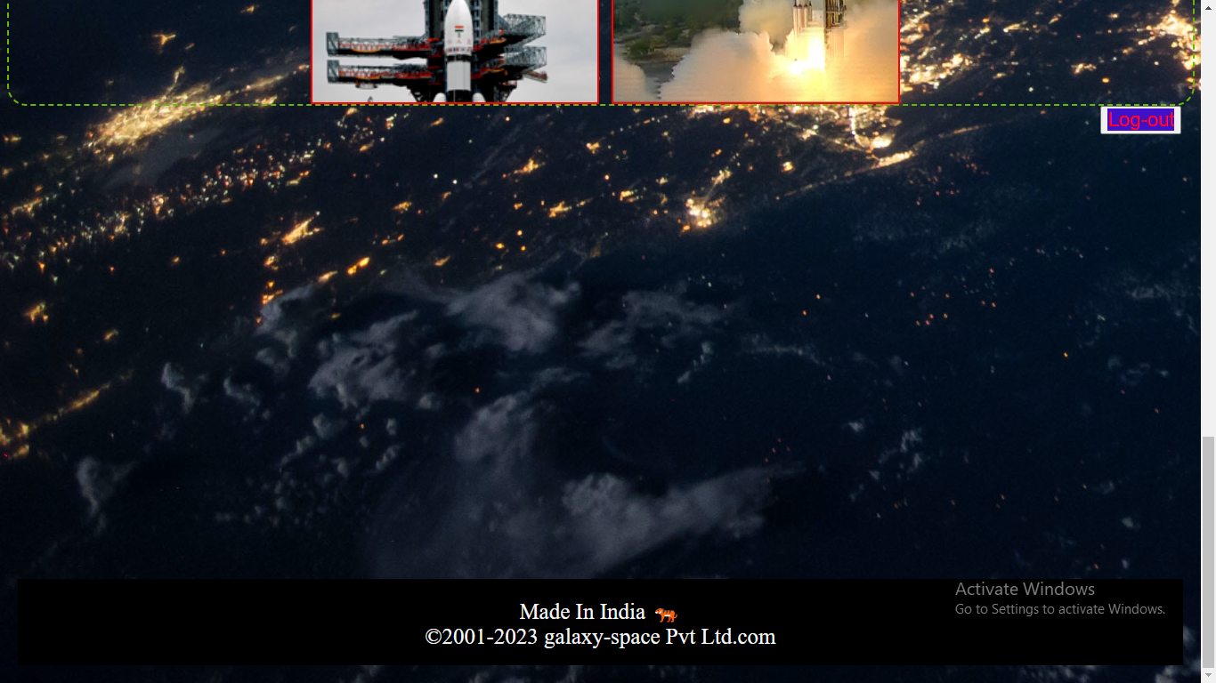

**”Top & bottom view of website”**

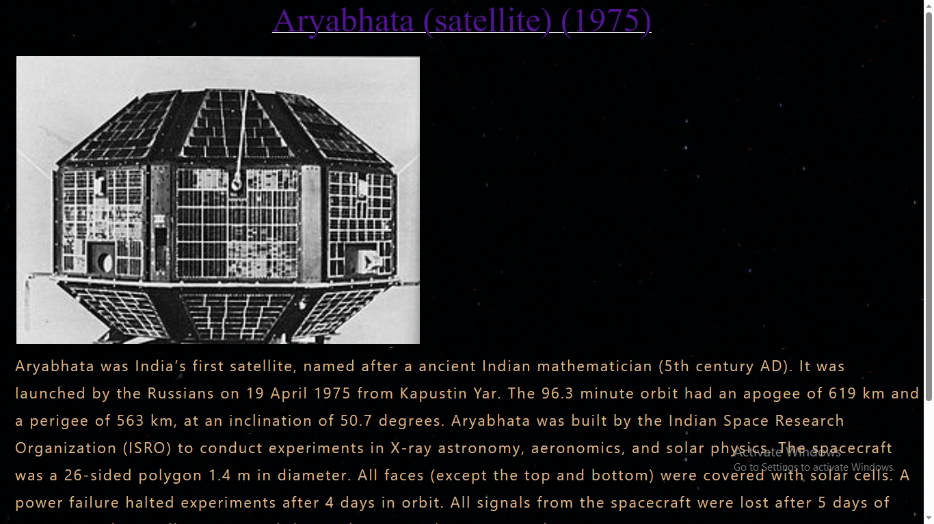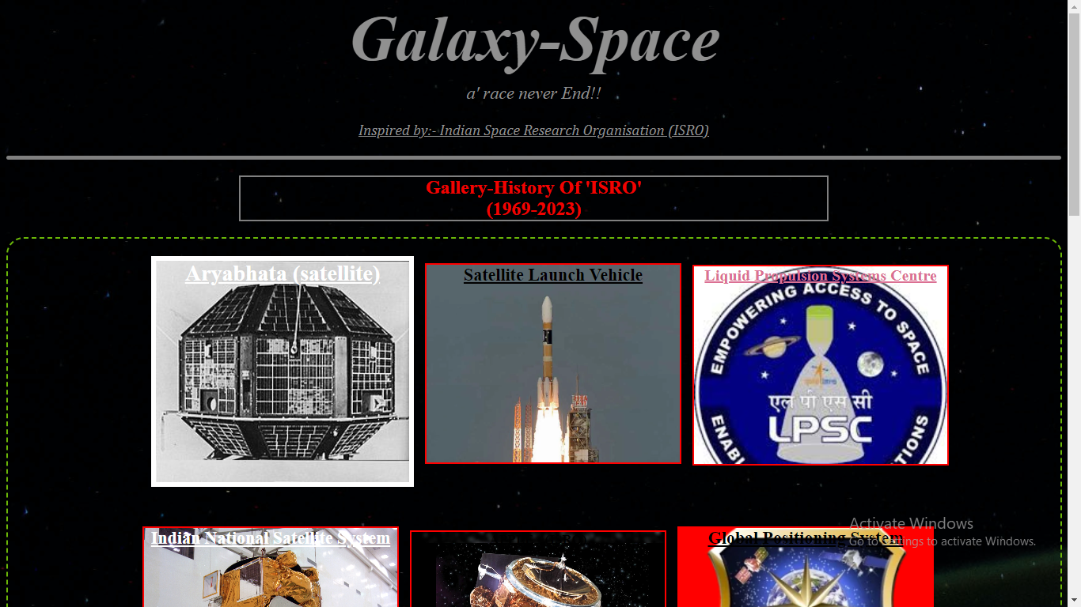**“Click Image to view a story”**